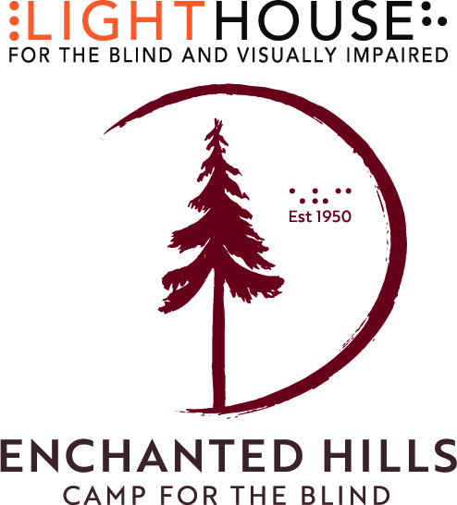
FAQs
When was EHC founded? Rose Resnick, a blind musician, teacher and philanthropist founded Enchanted Hills in 1950: the first camp of its kind on the West Coast. 2020 was the 70th anniversary of the camp’s founding.
What is the vision? To create a modern, custom designed, universally accessible indoor/ outdoor camp, international training and retreat center on 311 acres above Napa Valley.
Why is this important? Enchanted Hills Camp is now the only camp serving blind and low vison babies, youth, adults and their families in the American West.
How many new structures will be built at Enchanted Hills Camp?
- The Blindness Training Lab and STEM Center
- The Forest Commons training kitchen, dining and program space
- Six new winterized and heated family cabins
- Four new winterized camper bunkhouses
- Spacious, new pool house and shade structure
- Accessible multi-sport court
- Accessible farm with animals, vegetable gardens and fruit orchard
- Tactile Arts Center
- Miles of accessible hiking trails and camping platforms
- Three new footbridges
- Replacement stage in the outdoor Redwood Grove Amphitheater
- Fully accessible treehouse
- A net-zero energy footprint, powered by camp-wide solar power
- Reforestation of the property with oak and redwood saplings
- Improvements to necessary camp infrastructure: roads, electrical, water, broadband internet, emergency power, and fire safety abatement
When will this happen? Phase I is already complete with renovation of the camp’s legacy buildings, new pool house and shade structure and new spacious utility garage with office. Phase II is slated to begin October 2022.
Where are the funds coming to transform Enchanted Hills Camp? Approximately $23 million in funds will come from fire insurance proceeds, damage settlements and other non-charitable sources, including the Lighthouse’s own endowment. Enchanted Hills Camp Capital Campaign goal is $10 million.
How can gifts be made? Charitable, tax-deductible contributions and grants can be made as immediate gifts, as multi-year pledges, in stock transfer, or as in-kind contributions. Lighthouse for the Blind and Visually Impaired is a 501(c)(3) tax-exempt, nonprofit organization.
How many programs are offered at Enchanted Hills each year? On average EHC offers 14 programs for blind and low vision individuals and families.
How many campers attend camp? In a typical year, 450 campers and their families enjoy more than 18,000 hours of programming at EHC each year.

